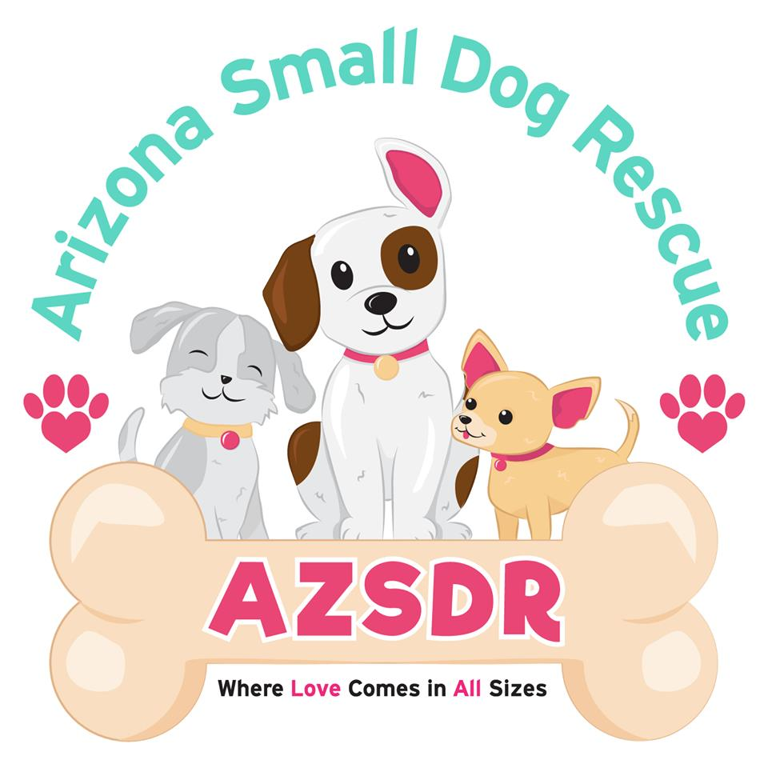
Dog name: Click or tap here to enter text.
Input _____________________
Scan ______________________
A# _______________________
R# _______________________

Dog Adoption Application (v.2021 Feb)
Name: Click or tap here to enter text.
Address: Click or tap here to enter text. Apt #: Click or tap here to enter text.
City: Click or tap here to enter text. State: Click or tap here to enter text. Zip: Click or tap here to enter text.
Phone: Click or tap here to enter text. Alternative Phone: Click or tap here to enter text. Email: Click or tap here to enter text.
Employer: Click or tap here to enter text. Position: Click or tap here to enter text.
Emergency contact Name: Click or tap here to enter text. Phone: Click or tap here to enter text.
Who will take care of this dog if you become unable to care for him/her? (required)
Name: Click or tap here to enter text. Phone: Click or tap here to enter text.

If you live in an apartment, are there pet restrictions & what are they? Click or tap here to enter text.
If you live in an apartment, provide the apartment name: Click or tap here to enter text.
# of adults in your home: Click or tap here to enter text. Do you rent or own? Own
If rent, landlord's name: Click or tap here to enter text. Landlords phone#: Click or tap here to enter text.

Are all family members aware that you are considering adopting a dog? Click or tap here to enter text.
# of children in your home Choose an item. How old are the children? Click or tap here to enter text.
Have they been around dogs? Click or tap here to enter text.
# of pets in your home: Click or tap here to enter text. Are they fixed? Click or tap here to enter text.
Are they current on shots? Click or tap here to enter text. Do you have a vet? Click or tap here to enter text.
Please describe your current pet’s breeds and ages: Click or tap here to enter text.
How many hours a day will your dog be alone? 3-5 hours
Will you crate your newly adopted dog? Click or tap here to enter text.
Where will the dog be kept when you aren’t home? Click or tap here to enter text.
Where will the dog spend most of its time? Click or tap here to enter text.
Where will the dog sleep at night? Click or tap here to enter text.

Do you have a doggy door? Choose an item. Do you have a pool? Choose an item. Is it fenced? Choose an item.
Type of pool fence: Click or tap here to enter text.
Describe your yard and its fencing: Click or tap here to enter text.
If you don’t have a yard how will you exercise your dog? Click or tap here to enter text.

Have you had other pets in the last 5 years that are no longer with you? ☐ Yes ☐ No
What happened to them if so? Click or tap here to enter text.
Have you ever returned or given an animal to another rescue, shelter, or county animal control facility? ☐ Yes ☐ No If yes, please explain: Click or tap here to enter text.
Have you ever had a dog or puppy become sick from parvo-virus? ☐ Yes ☐ No
If yes, how long ago: Click or tap here to enter text.
Why do you want to adopt a dog? Click or tap here to enter text.

The dog you are adopting may need to be provided structure and some training. What behaviors are you willing & able to work with? Check the ones below you are willing to work with:
☐ House training ☐ Crate training ☐ Leash training ☐ Separation anxiety ☐ Chewing ☐ Nipping/Biting
What would this dog have to do for you to consider returning him/her to Arizona Small Dog Rescue? Click or tap here to enter text.
Do you understand that adopting a rescue dog is forever? We want these dogs to never be re-homed again. Are you willing to put in the work to make sure your adopted dog adjusts, and fits into your life, even if it involves training? Click or tap here to enter text.
How did you hear about us or hear about the pet you are adopting? Click or tap here to enter text.
I have read the above information carefully and have filled out this application honestly. I understand that omission of information and/or failure to answer all questions and sign the application can result in this application being declined. Also, if an omission or untruth is discovered after an adoption takes place, I understand that the Arizona Small Dog Rescue reserves the right to annul the adoption and reclaim the animal. By electronically signing below, I agree to the above.

Signature Click or tap here to enter text. Date Click or tap here to enter text.

